ICMP Protocol Analysis – Wireshark
- Key ICMP Fields:
Field Name | Description
Type | Defines the ICMP message type
Code | Provides further detail for the type
Checksum | Error-checking for header
Identifier | Helps match requests and replies
Sequence No. | Sequence of the request/reply
Data | Optional payload

- Used these filters in Wireshark’s Display Filter bar:
Filter | Description
- icmp | Shows all ICMP traffic
- icmp.type == 8 | Shows Echo Requests (ping)
- icmp.type == 0 | Shows Echo Replies
- icmp.code == 3 | Destination unreachable
- ip.addr == 192.168.1.10 | ICMP traffic from/to specific host

- Wireshark filter screenshots:

ICMP traffic
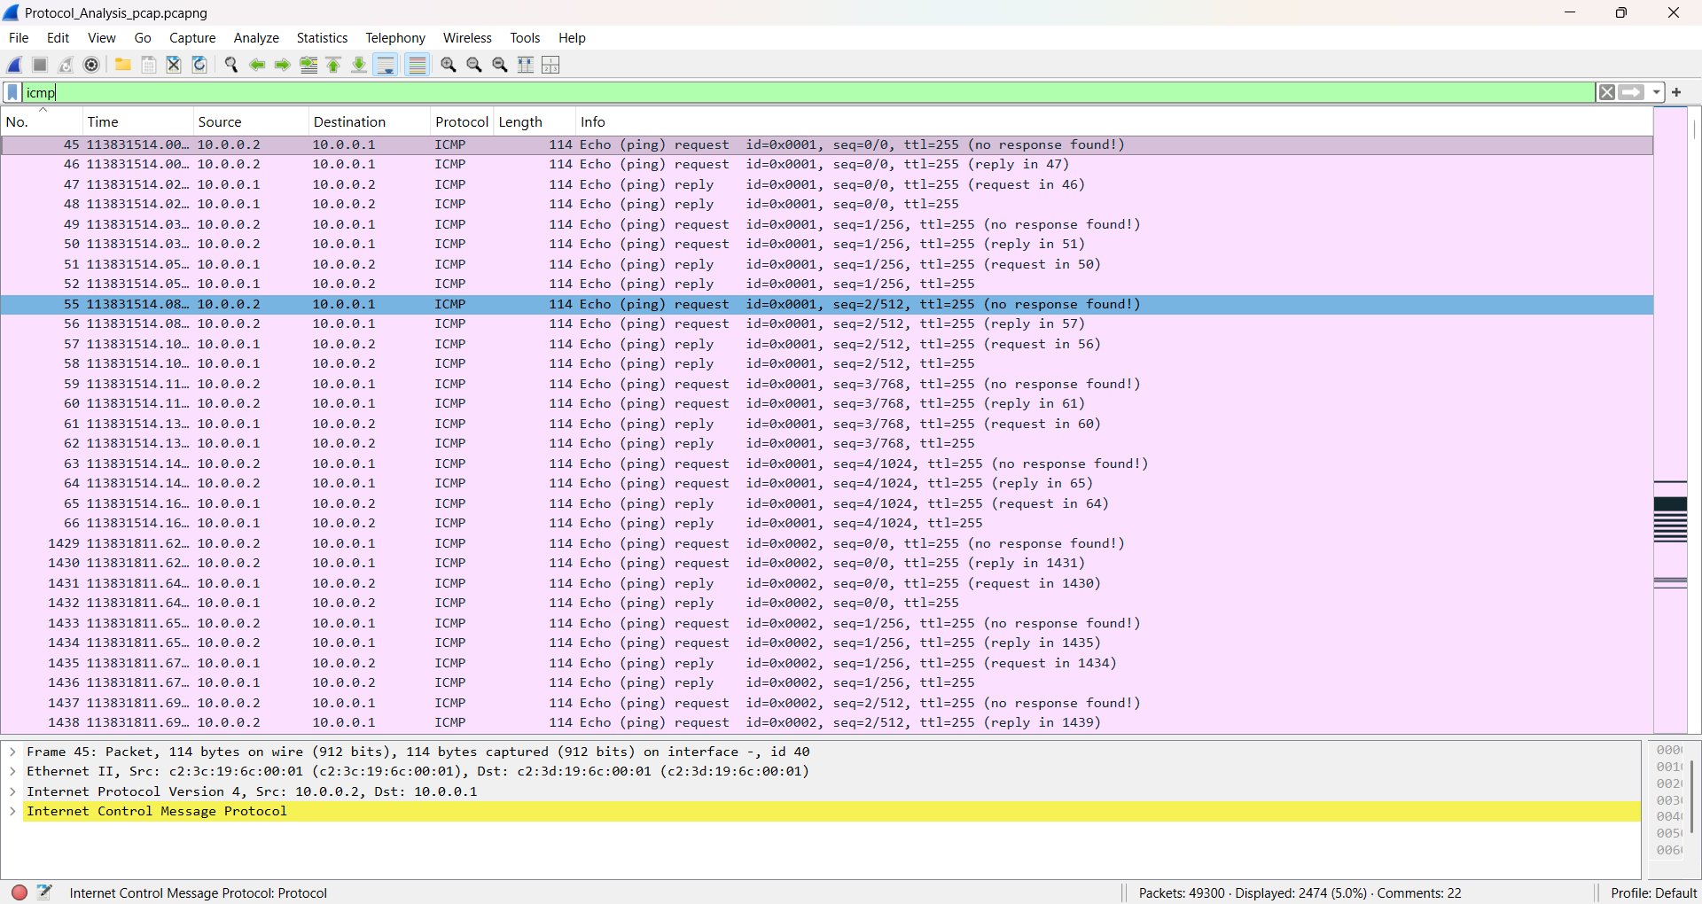

Shows all Echo Request of ICMP
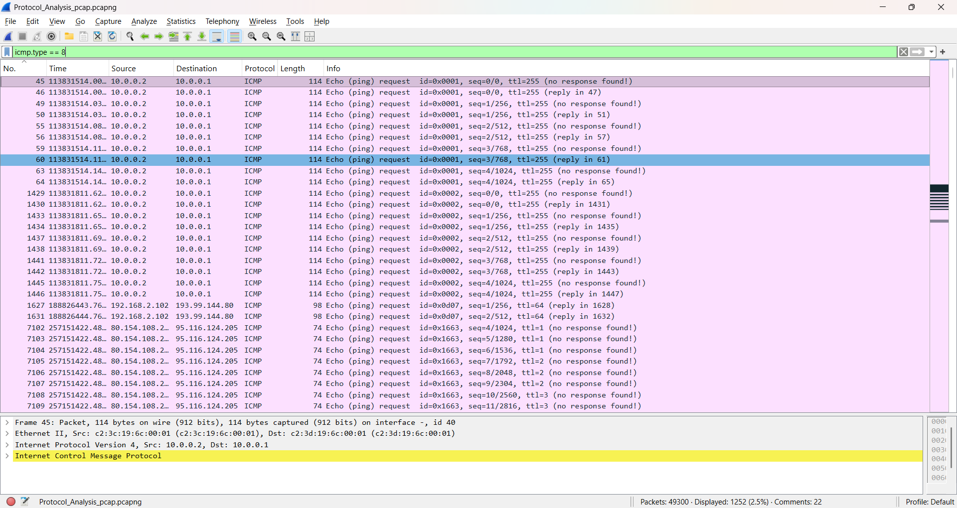

Shows Echo Reply of ICMP
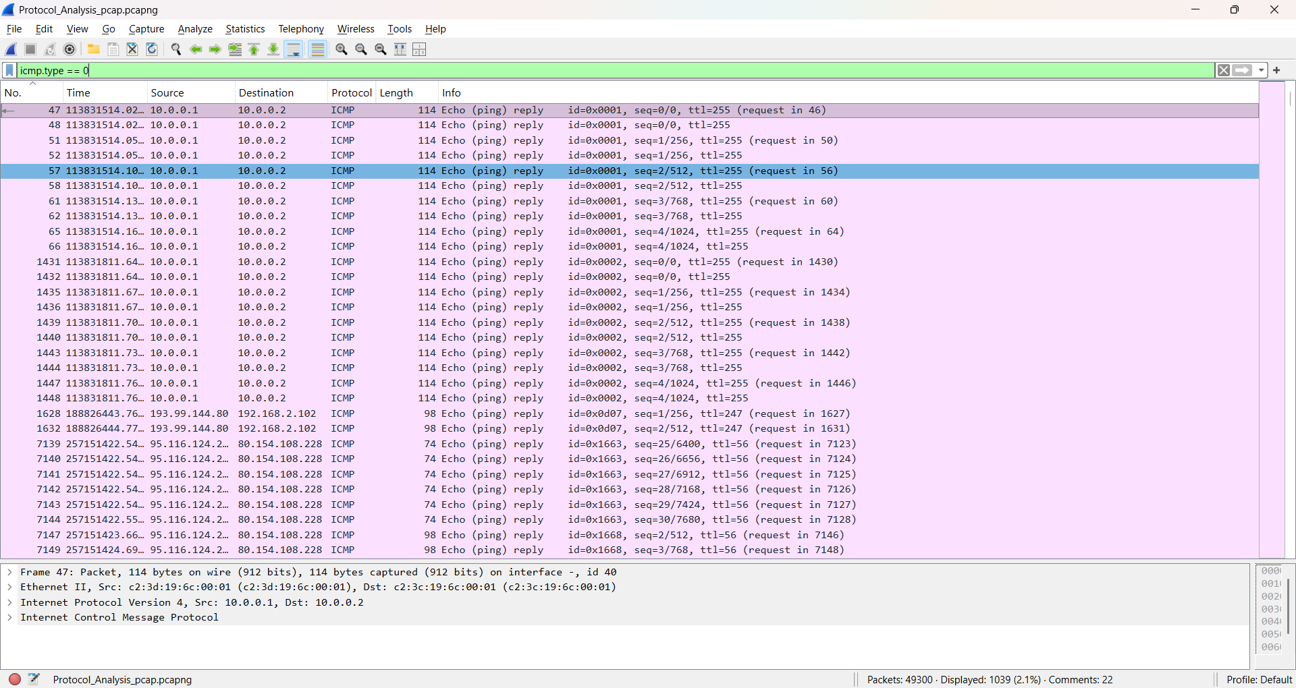

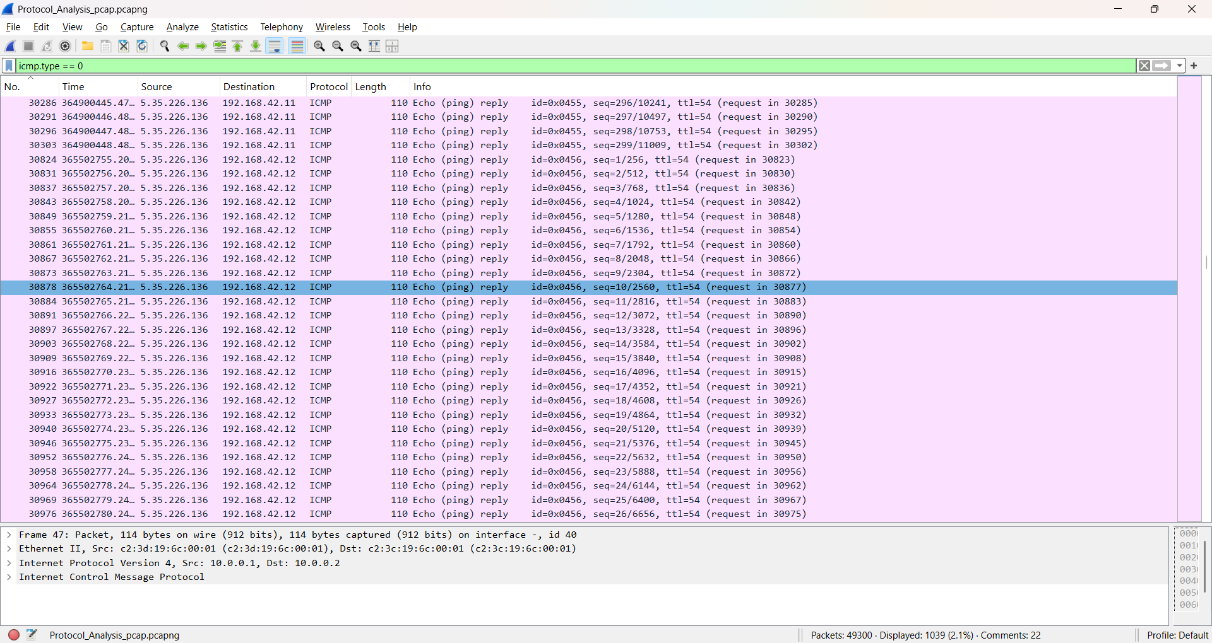

Destination unreachable
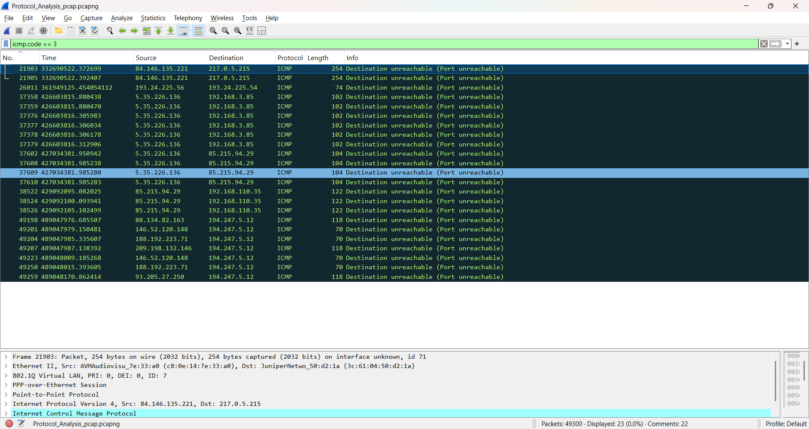

ICMP traffic from/to specific host
